**Project Design Phase-II**

**Data Flow Diagram & User Stories**

|  |  |
| --- | --- |
| Date | 20 May 2023 |
| Team ID | NM2023TMID13273 |
| Project Name | The future of work: Data analysis of glassdoor job |

**Data Flow Diagrams:**

A Data Flow Diagram (DFD) is a traditional visual representation of the information flows within a system. A neat and clear DFD can depict the right amount of the system requirement graphically. It shows how data enters and leaves the system, what changes the information, and where data is stored.



Example: DFD Level 0 (Industry Standard)

**Example:**

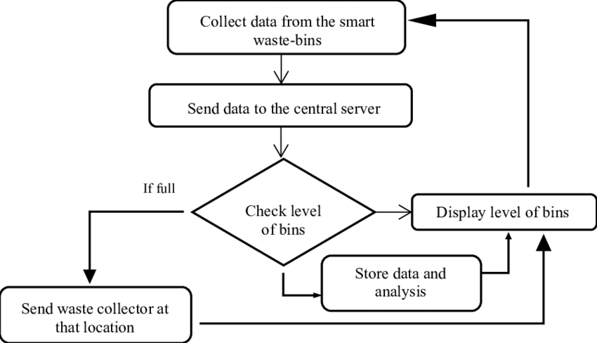

**User Stories**

Use the below template to list all the user stories for the product.

| **User Type** | **Functional Requirement (Epic)** | **User Story Number** | **User Story / Task** | **Acceptance criteria** | **Priority** | **Team Member** |
| --- | --- | --- | --- | --- | --- | --- |
| End User | Garbage Classification | USN-1 | As an end user, I want the intelligent garbage classification system to accurately identify and classify different types of garbage. | The system should be able to classify garbage items into predefined categories such as recyclable, organic, and non-recyclable. | High | Kesavan |
|  |  | USN-2 | As an end user, I want the garbage classification system to provide clear instructions on how to dispose of each classified item. | After classifying an item, the system should provide detailed instructions on how to dispose of it properly. | Medium | Sathriyan |
|  |  | USN-3 | As an end user, I want the garbage classification system to have a user-friendly interface. | The system should provide clear instructions on how to use the interface for capturing and uploading garbage images. | Medium | Dhanush |
|  |  | USN-4 | As an end user, I want the garbage classification system to continuously improve its classification accuracy. | The system should have a feedback mechanism where users can provide feedback on misclassified items. | High | Nithish Kumar |
|  |  | USN-5 | As an end user, I want the garbage classification system to handle a diverse range of garbage items. | The classification performance should not be significantly affected by variations in garbage item appearance. | High | Praveenraj |
| System Administrator | Garbage Classification Management | USN-6 | As a system administrator, I want to be able to manage the garbage classification system's data. | The system should allow me to view and manage the garbage classification data, including accuracy metrics, feedback from users, and performance reports. | High | kesavan |
| Customer Care Executive |  | USN-7 | As a system administrator, I want to monitor the garbage classification system's performance and health. | The system should alert me if there are any performance issues or errors that require attention. | High | Sathriyan |
| Developer | Garbage Classification Development | USN-8 | As a developer, I want to be able to access the garbage classification system's codebase. | The codebase should follow best practices for deep learning development, including proper data preprocessing, model training, and validation. | High | Dhanush |
|  |  | USN-9 | As a developer, I want to be able to integrate the garbage classification system with other systems. | The system should have a well-defined API that can be used for integrating with other systems. | Medium | Nithish Kumar |
|  |  |  |  |  |  |  |
|  |  |  |  |  |  |  |